Year 11 –

(AO6)
TECHNICAL ACCURACY –
Literacy Skills

Student Self-Assessment

I am able to label sentences with some accuracy (L2)
I am able to show some control of a range of punctuation (L2)
I am able to attempt a variety of sentence forms (L2)
I am able to make some use of Standard English with some control of agreement (L2)
I am able to spell simple and more complex words accurately (L2)
I make use of varied vocabulary (L2)

I am able to mark sentences in a way that is mostly secure and accurate (L3)
I am able to use a range of punctuation, mostly with success (L3)
I am able to make use of a variety of sentence forms for effect (L3)
I am able to use Standard English mostly accurately, including control of grammatical structures (L3)
I am able to be generally accurate with my spelling, including complex and irregular words (L3)
I am able to make use of increasingly sophisticated vocabulary (L3)

I am able to mark sentences with consistent accuracy throughout (L4)
I am able to use a wide range of punctuation with a high level of accuracy (L4)
I am able to use a full range of appropriate sentence forms for effect (L4)
I am able to use Standard English securely throughout, including complex grammatical structures (L4)
I am able to write with a high level of accuracy in spelling, including ambitious vocabulary (L4)
I am able to use extensive and ambitious vocabulary (L4)

CAPITAL LETTERS-When to Use Capital Letters
Read each rule – then write an example in the box provided:
Student own example:
Rule 1:
To Start a Sentence
There are no exceptions to this rule.
This means that, after a full stop, you always use a capital letter.

Rule 2:
Titles
In titles, capitalise only the important words, not minor words such as ‘and’ and ‘but’.

Rule 3:
For Proper Nouns
Proper nouns name something specific, for example, Jane, John, Oxford University, Denver, Qantas, Microsoft, Everest, Sahara

Rule 4:

Acronyms (eg British Broadcasting Corporation – BBC)

Acronyms generally work like title case: you capitalise the important words, and not ‘and’, ‘of’, ‘for’ and so on.

Rule 5:

Contractions
For contractions, capitalise the initial letters of words, but not subsequent letters within the same word.

Contractions are like acronyms, but also include one or more letters from within the same word. Example of this: SciFi, short for science fiction.

Rule 6:

Overusing Capitals is Rude
WRITING ENTIRELY IN BLOCK CAPITALS IS SHOUTING, and it’s rude.

Copy out the paragraph and put in capital letters, full stops and commas.
A.
it was a freezing cold day. It had been snowing all night in london. tom and i went outside to play in the fresh snow. we hadn’t seen this much snow since we went skiing in france last year! Uncle toby was right when he said that we would wake up this morning and see white. Tom and I decided to make a snowman in the garden. he started to roll a huge ball for the body whilst i worked on the head. Then we ran inside and asked mum for a carrot for the nose. we then found pebbles for the eyes and mouth. we called our snowman jack.

B. Now write a paragraph about your journey in to school using capital letters accurately

Re-write these sentences using capital letters, full stops/exclamation/question marks
- who was the first person to land on the moon

- i hope the christmas holidays come soon

- i live just off smethwick high street, in the west midlands

- stop hitting me

- my g.p. is called dr. singh

- is it going to be august soon

- does david cameron work for queen Elizabeth

- stop it watch what you’re doing

- don’t shout at me

- where is the bull ring is it in birmingham or Wolverhampton

- my grandma watson lived in scotland until she was 80

- my auntie eleanor worked for a paint company in Glasgow

- what are you doing

Example of a very good descriptive piece of writing

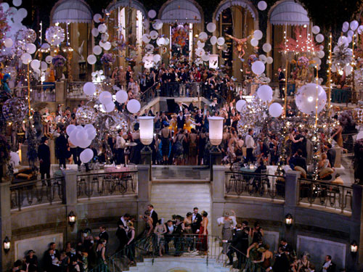
By seven o’clock the orchestra has arrived—no thin fivepiece affair but a whole pitful of oboes and trombones and saxophones and viols and cornets and piccolos and low and high drums. The last swimmers have come in from the beach now and are dressing upstairs; the cars from New York are parked five deep in the drive, and already the halls and salons and verandas are gaudy with primary colors and hair shorn in strange new ways and shawls beyond the dreams of Castile. The bar is in full swing and floating rounds of cocktails permeate the garden outside until the air is alive with chatter and laughter and casual innuendo and introductions forgotten on the spot and enthusiastic meetings between women who never knew each other’s names.
The lights grow brighter as the earth lurches away from the sun and now the orchestra is playing yellow cocktail music and the opera of voices pitches a key higher. Laughter is easier, minute by minute, spilled with prodigality, tipped out at a cheerful word. The groups change more swiftly, swell with new arrivals, dissolve and form in the same breath—already there are wanderers, confident girls who weave here and there among the stouter and more stable, become for a sharp, joyous moment the center of a group and then excited with triumph glide on through the seachange of faces and voices and color under the constantly changing light.
Suddenly one of these gypsies in trembling opal, seizes a cocktail out of the air, dumps it down for courage and moving her hands like Frisco dances out alone on the canvas platform. A momentary hush; the orchestra leader varies his rhythm obligingly for her and there is a burst of chatter as the erroneous news goes around that she is Gilda Gray’s understudy from the ‘Follies.’ The party has begun.
Extract: The Great Gatsby – S Fitzgerald

Quiz-Punctuation
Level A-Circle the right answer for each question.

1) Capital letters are used correctly in one of these dates. Which one?
A) Tuesday 1st august
B) TueSdaY 1st AuGust
C) Tuesday 1st August

2) Capital letters are used correctly in one of these sentences. Which
one?
A) I go to work on Tuesdays and Thursdays.
B) I go to work on tuesdays and Thursdays.
C) i go to work on Tuesdays and Thursdays.

3) Capital letters are used correctly in one of these sentences. Which
one?
A) Sammi is my Brother.
B) sammi is my brother.
C) Sammi is my brother.

4) How many capitals are needed in this sentence?
sally and ted work in doncaster.
A) one
B) two
C) three
D) four

Answers
1) Capital letters are used correctly in one of these dates. Which one?
The correct answer is C. 'Tuesday 1st August' uses capital letters
correctly.

2) Capital letters are used correctly in one of these sentences. Which
one?
The correct answer is A. 'I go to work on Tuesdays and Thursdays'
uses capital letters correctly.

3) Capital letters are used correctly in one of these sentences. Which
one?
The correct answer is C. 'Sammi is my brother' uses capital letters
correctly.

4) How many capitals are needed in this sentence?
The correct answer is C. Three capitals are needed - Sally, Ted and
Doncaster. Sally and Ted work in Doncaster

Improve your vocabulary choice!
 | Synonym (1) | Synonym (2) | Synonym (3) | Synonym (4)
Angry
Answer
Ask
Awful
Bad
Beautiful
Begin
Brave
Break
Bright
Calm
Come
Cool
Crooked
Cry
Dangerous
Dark
Decide
Definite
Delicious
Describe

APOSTROPHES OF POSSESSION
An apostrophe is normally used with the letter s to show ownership or possession. With most singular nouns, simply add an apostrophe plus the letter s to do this. An apostrophe plus s is never added to make a noun plural--even a proper noun.
Student own example:
Possession- Use an apostrophe to show possession (one thing belongs to another).

It was the dog's bone.

Add 's to dog to show the bone belonged to it.

Amy's dad was late picking her up from the cinema.

Add 's to Amy to show that it was her dad who was late.
Plural Possessives- To make a plural noun possessive, simply add an apostrophe to the word. If the plural does not end in an s, then add an apostrophe plus s.

Examples:
The girls' dresses (The dresses belonging to the girls.)
The Wilsons' house (The Wilsons live in the house.)
The men's room (Plural does not end in s.)

Omission-You can also use apostrophes to show that you have omitted (left out) some letters in a word, or when joining words together.
Without omission With omission
you have you've
we have we've
it is it's
do not don't
could not couldn't
is not isn't

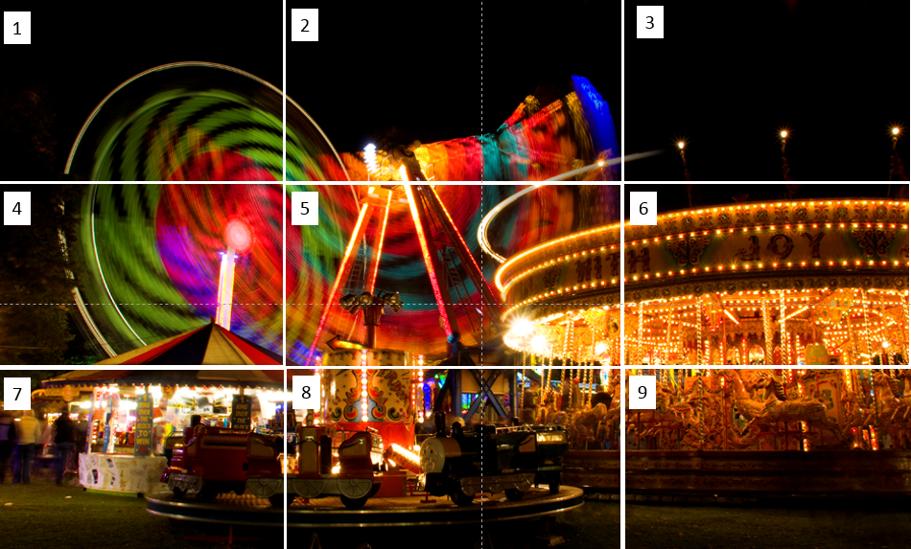
(Refer back to The Great Gatsby extract for help)
- Your first sentence must start with a verb ending in ‘ing’
- Your second sentence must contain only three words.
- Your third sentence must be a complex sentence
- Your fourth sentence must be a rhetorical question
- Your fifth sentence will start with an adverb comma –ly,
- Your sixth sentence will contain a simile
- Your seventh sentence will start with an estimation of time
- Your eighth sentence will use two of the senses.
- Your ninth sentence will use an exclamation
- Your tenth sentence will use dialogue.

Possessive Apostrophes
Instructions: Rewrite each of these noun phrases as a possessive noun followed by another noun. Use previous knowledge of capital letters to re-write. The first one has been done for you:

1. the pain of the runner | The runner’s pain.
2. the visit of the class
3. the price of the shirt
4. the price of the shirts
5. the pets of everyone
6. the speed of the car
7. the speed of the cars
8. the roar of the ocean
9. the value of something
10. the recipe of my mother-in-law
11. the plan of the committee
12. the results of the competitions
13. the experience of the manager
14. the essays of the student
15. the essays of the students
Possessive Apostrophes
Instructions: In the following paragraph, no apostrophes have been used. Underline each word that should have an apostrophe and rewrite the word below, using apostrophes where they are needed.
Student own example:
Its hard to understand why people decide to buy certain cars. Even though a persons old car might be running fine, once he sees one of the new models, hes not going to be happy until he has traded in his old car. John, one of my best friends, is a good example of a victim of “new car fever.” Johns 1993 Camaro was running fine, but when he saw the advertisements for the 1996 Camaro, with more valves for extra fuel injection and a sleek, sporty new air foil, he thought of thousands of reasons why he needed a new car. Johns girlfriend didn’t see much of him for several Saturdays while he was listening to this salesmans sales pitch and looking at that dealers display. Meanwhile, his girlfriend had started going out with an old friend of hers and Johns. She says she doesn’t mind going out in her new boyfriends 1968 pickup at all. Now Johns got a new car, but is looking for a new girl to go out with, preferably one who will be impressed with his new cars extra valves.

Instructions: In the following paragraphs, add an apostrophe wherever necessary.
Student own example:
Ethans house is a world of its own. Downstairs lives his Uncle Abe, who takes advantage of his sisters hospitality by living rent-free. Ethans fear prevents him from ever entering Abes apartment. Abes old, yellow teeth and his stringy hair frighten Ethan. Upstairs, in the front room, Ethans parents sit for hours and talk, oblivious to the old man in the basement. Pete, the familys old beagle, sprawls on a hooked rug. In the back room, the boys play ping-pong. Ethans ping-pong table takes up the entire room, leaving a space of less than eighteen inches for each of the players. Ethans and Mikes gentle “pinging” and “ponging” almost covers the noise from the basement.
On the front porch, Ethans girlfriend, Becky, sits with his grandmother and shells peas. The plunk, plunk, plunk of the peas landing in the round tin tray blends with the raindrops drumming on the screens and the ping-pong balls tapping back and forth inside. Becky hasn’t heard Abes sawing and banging in the basement. Of course, no one in the neighborhood realizes what is happening beneath the familys house until the cops sirens tear through the peaceful evening. Perhaps everyones uncle is not an escapee from the state penitentiary, but Ethans is.
4
Improve your vocabulary choice!
 | Synonym (1) | Synonym (2) | Synonym (3) | Synonym (4)
Destroy
Do
Dull
Eager
End
Enjoy
Explain
Fair
Fall
False
Famous
Fast
Fat
Fear
Fly
Funny
Get
Good
Great
Gross
Happy

Refer back to The Great Gatsby extract for help)

Apostrophe quiz!

The news said that ___ going to rain tomorrow.
- it's
- it
- its

He always carries ___ of his family.
- picture's
- pictures
- pictures'

Simon, Johnny, Paul and Peter were playing. Lisa came and kicked the ___ ball away.
- boy's
- boys'
- boys

I've never seen ___ before.
- it
- its
- it's

Where did you leave ___ bike?
- you're
- you
- your

I ___ see anything from where I was sitting.
- could'nt
- couldnt
- couldn't

___ leaving in 5 minutes.
- Wer'e
- We're
- Were

___ lessons are really good!!
- Mr.McCarthys'
- Mr.McCarthys
- Mr.McCarthy's

A snake uses ___ tongue to sense what is happening around it.
- it
- it's
- its

The ___ nice today.
- weathers'
- weather's
- weather

___ name is Sam, isn't it?
- Your
- Yours
- You're

___ my best friend.
- You're
- You
- Your

We only sell ___ in this shop.
- apples
- apple's
- apples'

ANSWERS

It’s
Pictures
Boys’
It
Your
Couldn’t
We’re
Mr McCarthy’s
Its
Weather’s
Your
You’re
Apples

SEMI-COLONS
The semicolon [ ; ] is a powerful mark of punctuation with three uses. a semicolon should be used to separate two independent clauses (or complete sentences) that are closely related in meaning.

Student own example:
The first appropriate use of the semicolon is to connect two related sentences. The pattern looks like this:

Grandma still rides her Harley motorcycle; her toy poodle balances in a basket between the handlebars.

A semicolon can also team up with a transition—often aconjunctive adverb—to connect two sentences close in meaning. The pattern looks like this:

My father does not approve of his mother cruising around town on a Harley motorcycle; however, Grandma has never cared what anyone thinks.

Finally, use the semicolon to avoid confusion when you have complicated lists of items. The pattern looks like this:

On a Harley motorcycle, my grandmother and her poodle have traveled to Anchorage, Alaska; San Francisco, California; and Tijuana, Mexico.

Mini Quiz
Correct the following incorrect semi-colons:

- Incorrect: I had a great weekend; visiting with friends, playing golf, and eating at a nice restaurant.
Correct:

- Incorrect: Next weekend, I plan to go hiking; which is one of my favourite activities.
Correct:
- Incorrect: It might rain next weekend, though; so I might have to stay inside.
Correct:

- Incorrect: I like to spend time outdoors; and I can't stand to stay inside.
Correct:

Answers

- Incorrect: I had a great weekend; visiting with friends, playing golf, and eating at a nice restaurant.
Correct: I had a great weekend; I visited with friends, played golf, and ate at a nice restaurant.
- Incorrect: Next weekend, I plan to go hiking; which is one of my favorite activities.
Correct: Next weekend, I plan to go hiking; hiking is one of my favorite activities.
- Incorrect: It might rain next weekend, though; so I might have to stay inside.
Correct: It might rain next weekend, though, so I might have to stay inside.
Correct: It might rain next weekend, though; I might have to stay inside.
- Incorrect: I like to spend time outdoors; and I can't stand to stay inside.
Correct: I like to spend time outdoors; I can't stand to stay inside.

Refer back to The Great Gatsby extract for help)

Improve your vocabulary choice!
 | Synonym (1) | Synonym (2) | Synonym (3) | Synonym (4)
Hate
Have
Help
Hide
Hurry
Hurt
Idea
Important
interesting
Keep
Kill
Lazy
Little
Look
Love
Make
Mark
Mischievous
Move
Moody
Neat

Is the semicolon used correctly in the sentence below?

George Orwell's essay "Shooting an Elephant" is about a rampaging elephant; and Orwell's decision to shoot this elephant.

? The semicolon is correct.
? The semicolon is incorrect.

George Orwell's essay "Shooting an Elephant" is about a rampaging elephant; Orwell relunctantly decides to shoot this elephant.

? The semicolon is correct.
? The semicolon is incorrect.

A draft of my first essay is due on Monday; I also need to read the second chapter of the textbook.

? The semicolon is correct.
? The semicolon is incorrect.

A draft of my first essay is due on Monday; and I also need to read the second chapter of the textbook.

? The semicolon is correct.
? The semicolon is incorrect.

I enjoyed spending a week in Florida; however, it was nice to return home after the long vacation.

? The semicolon is correct.
? The semicolon is incorrect.

The sunny days in Florida; however, gave me a bad sunburn.
? The semicolon is correct.
? The semicolon is incorrect.

ANSWERS
Is the semicolon used correctly in the sentence below?

George Orwell's essay "Shooting an Elephant" is about a rampaging elephant; and Orwell's decision to shoot this elephant.
? The semicolon is correct.
? The semicolon is incorrect. CORRECT

George Orwell's essay "Shooting an Elephant" is about a rampaging elephant; Orwell relunctantly decides to shoot this elephant.
? The semicolon is correct. CORRECT
? The semicolon is incorrect.

A draft of my first essay is due on Monday; I also need to read the second chapter of the textbook.
? The semicolon is correct. CORRECT
? The semicolon is incorrect.

A draft of my first essay is due on Monday; and I also need to read the second chapter of the textbook.
? The semicolon is correct.
? The semicolon is incorrect. CORRECT

I enjoyed spending a week in Florida; however, it was nice to return home after the long vacation.
? The semicolon is correct. CORRECT
? The semicolon is incorrect.

The sunny days in Florida; however, gave me a bad sunburn.
? The semicolon is correct.
? The semicolon is incorrect. CORRECT

Student Self-Assessment

I am able to label sentences with some accuracy (L2)
I am able to show some control of a range of punctuation (L2)
I am able to attempt a variety of sentence forms (L2)
I am able to make some use of Standard English with some control of agreement (L2)
I am able to spell simple and more complex words accurately (L2)
I make use of varied vocabulary (L2)

I am able to mark sentences in a way that is mostly secure and accurate (L3)
I am able to use a range of punctuation, mostly with success (L3)
I am able to make use of a variety of sentence forms for effect (L3)
I am able to use Standard English mostly accurately, including control of grammatical structures (L3)
I am able to be generally accurate with my spelling, including complex and irregular words (L3)
I am able to make use of increasingly sophisticated vocabulary (L3)

I am able to mark sentences with consistent accuracy throughout (L4)
I am able to use a wide range of punctuation with a high level of accuracy (L4)
I am able to use a full range of appropriate sentence forms for effect (L4)
I am able to use Standard English securely throughout, including complex grammatical structures (L4)
I am able to write with a high level of accuracy in spelling, including ambitious vocabulary (L4)
I am able to use extensive and ambitious vocabulary (L4)

The following two paragraphs, you will find a number of empty paired brackets: [ ]. Re-write each paragraph and replace each set of brackets with a comma or a semicolon, keeping in mind that the primary use of a semicolon is to separate two main clauses not joined by a coordinating conjunction.
Exercise: Pasta

Pasta[ ] a large family of shaped[ ] dried wheat pastes[ ] is a basic staple in many countries. Its origins are obscure. Rice pastes were known very early in China[ ] pastes made of wheat were used in India and Arabia long before they were introduced into Europe in the 11th or 12th century.
According to legend[ ] Marco Polo brought a pasta recipe with him from Asia in 1295. Pasta quickly became a major element in the Italian diet[ ] and its use spread throughout Europe.
Pasta is made from durum wheat flour[ ] which makes a strong[ ] elastic dough. Hard durum wheat has the highest wheat protein value.

The flour is mixed with water[ ] kneaded to form a thick paste[ ] and then forced through perforated plates or dies that shape it into one of more than 100 different forms. The macaroni die is a hollow tube with a steel pin in its center[ ] the spaghetti die lacks the steel pin and produces a solid cylinder of paste. Ribbon pasta is made by forcing the paste through thin slits in a die[ ] shells and other curved shapes are produced with more intricate dies.
The shaped dough is dried carefully to reduce the moisture content to about 12 percent[ ] and properly dried pasta should remain edible almost indefinitely. Pastas can be colored with spinach or beet juice. The addition of egg produces a richer[ ] yellower pasta that is usually made in noodle form and is often sold undried.

Answers Paragraphs: Pasta
Pasta, a large family of shaped, dried wheat pastes, is a basic staple in many countries. Its origins are obscure. Rice pastes were known very early in China; pastes made of wheat were used in India and Arabia long before they were introduced into Europe in the 11th or 12th century.
According to legend, Marco Polo brought a pasta recipe with him from Asia in 1295. Pasta quickly became a major element in the Italian diet, and its use spread throughout Europe.
Pasta is made from durum wheat flour, which makes a strong, elastic dough. Hard durum wheat has the highest wheat protein value.

The flour is mixed with water, kneaded to form a thick paste, and then forced through perforated plates or dies that shape it into one of more than 100 different forms. The macaroni die is a hollow tube with a steel pin in its center; the spaghetti die lacks the steel pin and produces a solid cylinder of paste. Ribbon pasta is made by forcing the paste through thin slits in a die; shells and other curved shapes are produced with more intricate dies. The shaped dough is dried carefully to reduce the moisture content to about 12 percent, and properly dried pasta should remain edible almost indefinitely. Pastas can be colored with spinach or beet juice. The addition of egg produces a richer, yellower pasta that is usually made in noodle form and is often sold undried.

(Refer back to The Great Gatsby extract for help)

Commas
Commas customarily indicate a brief pause; they're not as final as a full stop.
Student own example:
Use commas to separate items in a list of three or more.
Remember that an “item” may refer to a noun, verb, or adjective phrase.

I need to buy eggs, milk, lettuce, and bread.

Use a comma to separate independent clauses (complete thoughts) when they are
joined by the following conjunctions:
and or for nor so but yet
Note: The comma should come before the conjunction

I want to buy the new jacket, but it is too expensive.

Use a comma to separate a dependent clause (incomplete thought) from an
independent clause (complete thought).
Without water, the plant will die.

Use a comma(s) to separate any word or phrase from the rest of the sentence that is not essential to the sentence's meaning. This phrase usually provides extra information about the subject.

My mother, on the other hand, does not like chocolate.

Improve your vocabulary choice!
 | Synonym (1) | Synonym (2) | Synonym (3) | Synonym (4)
New
Old
Part
Place
Plan
Popular
Put
Quiet
Right
Run
Say
Tell
Scared
Show
Slow
Stop
Story
Strange
Take
Think
Trouble

Missing Commas in Paragraphs-Directions: Read the paragraphs and add any needed commas.
My Friend's Visit
Jenny my best friend from summer camp is coming for a visit this weekend. Although she is from a big city with a lot of exciting things to do I am sure she will enjoy visiting our farm. She will enjoy swimming in our pond riding horses and picking berries for pies. My brother is afraid she will get bored on our farm but I think she will love it here. With all of the things Mom and I have planned she won't have time to be bored. I'm afraid she will however be very tired each night. Maybe this visit will be so much fun she will want to come back again next summer.
(9 missing commas)

Amazing Ice Cream If you want to know where to buy the most amazing ice cream in the state of Texas I can tell you. Amy's ice cream owned by my cousin has the creamiest most flavorful ice cream in the South. She offers some really exotic flavors like stinky fruit swirl and chocolate covered grasshopper delight, but she also offers normal flavors like chocolate vanilla strawberry etc. This variety is what makes her shop so popular. If you are ever in Houston you need to be sure and stop in for a taste. She is located at 298 Wesson Avenue Houston Texas. You won't be disappointed.
( 11 missing commas)

Answer Key
My Friend's Visit Jenny, my best friend from summer camp, is coming for a visit this weekend. Although she is from a big city with a lot of exciting things to do, I am sure she will enjoy visiting our farm. She will enjoy swimming in our pond, riding horses, and picking berries for pies. My brother is afraid she will get bored on our farm, but I think she will love it here. With all of the things Mom and I have planned, she won't have time to be bored. I'm afraid she will, however, be very tired each night. Maybe this visit will be so much fun she will want to come back again next summer. (9 missing commas)

Amazing Ice Cream If you want to know where to buy the most amazing ice cream in the state of Texas, I can tell you. Amy's ice cream, owned by my cousin, has the creamiest, most flavorful ice cream in the South. She offers some really exotic flavors like stinky fruit swirl and chocolate covered grasshopper delight, but she also offers normal flavors like chocolate, vanilla, strawberry, etc. This variety is what makes her shop so popular. If you are ever in Houston, you need to be sure and stop in for a taste. She is located at 298 Wesson Avenue, Houston, Texas. You won't be disappointed. (11 missing commas)

PARAGRAPHS
Paragraphs are a collection of sentences. They are used in writing to introduce new sections of a story, characters or pieces of information.
Paragraphs help readers to enjoy what has been written because they break text up in to easy-to-read sections.

Paragraphs can also be used to:
Student own example:
- Introduce new characters

- Introduce a new speaker or new dialogue

- Add suspense or change the mood

- Introduce a new theme

- Move between time / flashbacks

- Paragraphs in non fiction are usually used to introduce a new piece of information or a new point of view.
- In non-chronological reports, newspapers, biographies / autobiographies and instructions, new paragraphs are used to introduce a new piece of information.

Paragraphs - Quiz

1.What is a paragraph?
- A collection of sentences linked together by a common theme.
- An entire text.
- A collection of adjectives that describe characters.
2.Which of the following describes what a paragraph in a story does?
- Introduces a new scene, setting, character or new speech.
- Introduces a new piece of information such as where animals live or the effects of global warming.
- Rounds up the main points of the argument and concludes it.
3.Which of the following describes what paragraphs in newspaper reports do?
- Tells the story in a few words that capture attention.
- Breaks up the report into chronological order making it easier to read and understand.
- Introduces the main story.
4.Which of the following sentences would you expect to find at the beginning of a paragraph that introduces a new character?
- When the smoke had cleared, I saw him, six feet tall and covered in mud and blood.
- The forest floor was littered with leaves, bark and broken twigs.
- I was anxious when I walked into the classroom, but I knew I had to do it.
5.Paragraphs in a non-fiction text are used to...
- Introduce a new character.
- Introduce a new scene.
- Introduce a new piece of information.
6. A sub-heading is...
- A short title that informs the reader what a paragraph is about.
- A short title that informs the reader what the whole text is about.
- A connective.
7.Why does a plan help when writing paragraphs?
- It helps you concentrate.
- It helps to organise your writing into clear sections.
- It helps you to organise your adjectives.

8.Which of the following connectives is a good one to use in the final paragraph of an argument?
- Secondly
- Firstly
- In conclusion
9.
Which of the following is a connective?
- Furthermore
- Beautiful
- Unusual
10.
Which of the following is a good story plan that will help you to organise your writing into paragraphs and write an effective story?
- Headline, tag line, first paragraph, subheadings, conclusion
- Beginning, middle, end
- Beginning, set the scene, introduce problem, build the tension, resolution, conclusion

Answers
1.
What is a paragraph?
You said: A collection of sentences linked together by a common theme.
Correct.
Well done.
2.
Which of the following describes what a paragraph in a story does?
You said: Introduces a new scene, setting, character or new speech.
Correct.
Well done.
3.
Which of the following describes what paragraphs in newspaper reports do?
You said: Breaks up the report into chronological order making it easier to read and understand.
Correct.
Well done
4.
Which of the following sentences would you expect to find at the beginning of a paragraph that introduces a new character?
You said: When the smoke had cleared, I saw him, six feet tall and covered in mud and blood.
Correct.
Well done.
5.
Paragraphs in a non-fiction text are used to...
You said: Introduce a new piece of information.
Correct.
Well done.
6.
A sub-heading is...
You said: A short title that informs the reader what a paragraph is about.
Correct.
7.
Why does a plan help when writing paragraphs?
You said: It helps to organise your writing into clear sections.
Correct.
Well done.
8.
Which of the following connectives is a good one to use in the final paragraph of an argument?
You said: In conclusion
Correct.
Well done.
9.
Which of the following is a connective?
You said: Furthermore
Correct.
Well done.
10.
Which of the following is a good story plan that will help you to organise your writing into paragraphs and write an effective story?
You said: Beginning, set the scene, introduce problem, build the tension, resolution, conclusion
Correct.

Refer back to The Great Gatsby extract for help

SENTENCE VARIETY
You must vary your sentence structure. Try the following to help you.
1. Two adjective beginnings
The aim here is to start your sentence with two adjectives which describe the subject of the sentence. For example:
Exhausted and frustrated, the students finally finished their GCSE exams.
2. Starting with an ‘ing’ word
Starting your sentence with an ing word, leads into a clause which tells us
more about the subject of the sentence.

3. Beginning with an ‘ly’ word
For this third example of sentence variety, we begin the sentence with an
adverb (an ‘ly’ word) which gives us more detail on how the verb is performed.
Editing Exercises
Read the paragraphs. Rewrite all the sentences. Correct the writing mistakes.

did you no that bats are mammals. we no they are mammals just lik us becaus they are
warm blooded they are the only mammals that no how to fly bats are Nocturnal which
means thay sleep during the day and are awak at nite?

bes are intresting anumals. the honey be can fly at a sped of 15 miles per houre a hive of
honey bees has about 40,000 bees in it? the honey bee has five eyes! a worker bee will
mak 1/12th of a teespoon of honey over it’s lifetime? Bees have been makeing honey for
about 150 million years

did you no that a person can live with out food for more than a hole month a person can
only live four about won week with out water we need water more then we need food. 97 % of earths water is in the oceans. Just 3 % of the earths water can bee used four drinking
water. 75 % of the worlds fresh water is frozen in the North and South polar ice caps?

January 21, 1976 was an historic day. On that day, two supersonic Concorde aircraft made there first flights. One took of from London and the other from paris. Later that year, the first Concorde flew to New York. The flight from London to New York took about three ours. Other planes took twice the time to make that flight! The fleet of Concorde's was retierd in 2003. Over the years, the planes had carryed more then 2.5 million passengers.

Do you know wear the longest rode on Earth can be found. The Pan-American Highway begins in alaska. It passes through Canada the United States and Mexico. Than it continues down the west coast of South America all the way to Chile. Altogether, the highway passes through 12 countrys. It passes through jungles and mountains the road is about 16,000 miles long. At this time, only one 54-miles stretch of the road remains to be completed.

Are you familiar with the work of Marie Curie. Born in Warsaw Poland, on November 7, 1867, Curie was a Chemist and physicist. She and her husband, Pierre won the Nobel Prize in 1903 for there discovery of the element radium. In 1911, Marie becomes the first person to win the nobel Prize twice she won the second award for her study of radioactivity. Marie died in 1934 from cancer cause by her long contact with radiation.

Answers

Did you know that bats are mammals? We know they are mammals just like us because
they are warm blooded. They are the only mammals that know how to fly. Bats are
nocturnal which means they sleep during the day and are awake at night.

Bees are interesting animals. The honey bee can fly at a speed of 15 miles per hour. A
hive of honey bees has about 40,000 bees in it. The honey bee has five eyes. A worker
bee will make 1/12th of a teaspoon of honey over its lifetime. Bees have been making
honey for about 150 million years.

Did you know that a person can live without food for more than a whole month? A person can only live for about one week without water. We need water more than we need food. 97 % of earth’s water is in the oceans. Just 3 % of the earth’s water can be used for drinking water. 75 % of the world’s fresh water is frozen in the north and south polar ice caps.

January 21, 1976, was an historic day. On that day, two supersonic Concorde aircraft
made their first flights. One took off from London and the other from Paris. Later that year, the first Concorde flew to New York. The flight from London to New York took about three hours. Other planes took twice the time to make that flight! The fleet of Concordes was retired in 2003. Over the years, the planes had carried more than 2.5 million passengers.

Do you know where the longest road on Earth can be found? The Pan-American Highway begins in Alaska. It passes through Canada, the United States and Mexico. Then it continues down the west coast of South America all the way to Chile. Altogether, the
highway passes through 12 countries. It passes through jungles and mountains. The road is about 16,000 miles long. At this time, only one 54-mile stretch of the road remains to be completed.

Are you familiar with the work of Marie Curie? Born in Warsaw, Poland, on November 7,
1867, Curie was a chemist and physicist. She and her husband, Pierre, won the Nobel
Prize in 1903 for their discovery of the element radium. In 1911, Marie became the first
person to win the Nobel Prize twice. She won the second award for her study of
radioactivity. Marie died in 1934 from cancer caused by her long contact with radiation.

Refer back to The Great Gatsby extract for help

Level B-Circle the right answer for each question.

1) Capital letters are used correctly in one of these sentences. Which one?
A) The sports Centre opens at eight.
B) Five-a-side football starts at six on Mondays.
C) The shop stays open late on thursdays.

2) Capital letters are used correctly in one of these sentences. Which
one?
A) The summer programme starts on Monday 27 July.
B) The most Popular sessions are Swimming and circuit
training.
C) The programme ends at the beginning of september.

3) Which of these should start with a capital letter?
A) country
B) continent
C) scotland

4) Which of these should have capital letters?
A) football team
B) manchester united
C) rugby club

Answers

1) Capital letters are used correctly in one of these sentences. Which one?
The correct answer is B. 'Five-a-side football starts at six on
Mondays' uses capital letters correctly.

2) Capital letters are used correctly in one of these sentences. Which
one?
The correct answer is A. 'The summer programme starts on Monday
27 July' uses capital letters correctly.

3) Which of these should start with a capital letter?
The correct answer is C. Scotland should start with capital 'S'.

4) Which of these should have capital letters?
The correct answer is B. Manchester United should have capital
letters

These words are spelled wrong.
Can you correct them?

 | Your attempt | Check with a dictionary
atack
august
microfone
nescessary
scratsh
lizzard
millionare
carnifal
cieling
bagage
incredibel
langauge
propably
produse
horribul
humyliate
wurthwhile
zoologhist
ungratefull
tempareture

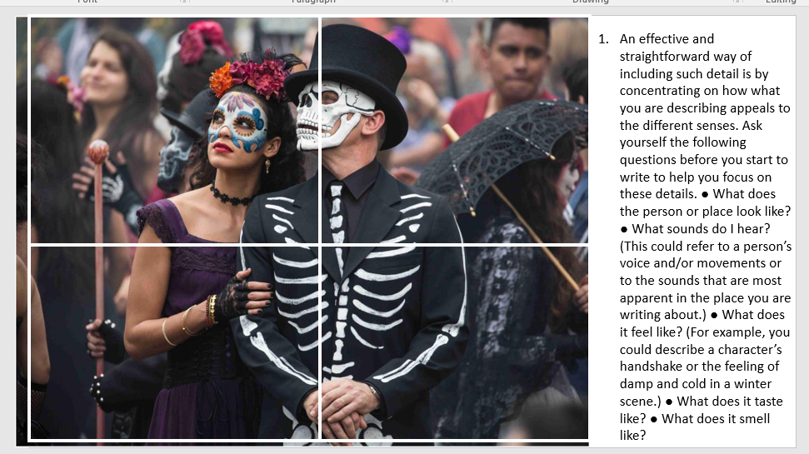
Refer back to The Great Gatsby extract for help

Level C -Circle the right answer for each question.

1) Which of these do not need to start with a capital letter?
A) the rooms in a house, for example Kitchen, Bedroom
B) the name of a street, for example, High Road
C) a postcode, for example N15 6BC

2) Which of these do not need to start with a capital letter?
A) names of cities, for example Birmingham, Coventry, Durham
B) names of vegetables, for example Cabbage, Peas, Potatoes
C) names of countries, for example, France, Scotland, Ireland

3) What punctuation is missing from this short text?
he didn't know what had happened he was away from home at the time

A) 1 full stop, 1 question mark and 1 capital letter
B) 2 full stops and 2 capital letters
C) 3 full stops and 3 capital letters
D) 2 full stops, 1 question mark and 1 capital letter

4) What punctuation is missing from this email message?
pat are you going to the match on saturday i hope i'll see you there

A) 1 full stop, 2 question marks and 4 capital letters
B) 3 full stops and 6 capital letters
C) 2 full stops, 1 question mark and 6 capital letters
D) 1 full stop, 1 question mark and 5 capital letters

Answers

1) Which of these do not need to start with a capital letter?
The correct answer is A. Rooms like kitchen and bedroom do not
need to start with a capital letter.

2) Which of these do not need to start with a capital letter?
The correct answer is B. Names of vegetables, for example cabbage,
peas, potatoes, do not need to start with capitals.
5) What punctuation is missing from this short text?
The correct answer is B. 2 full stops and 2 capital letters are needed.
He didn't know what had happened. He was away from home at the
time.

6) What punctuation is missing from this email message?
The correct answer is C. 2 full stops, 1 question mark and 6 capital
letters are needed. Hi Pat. Are you going to the match on Saturday? I
hope I'll see you there.

Student Self-Assessment

I am able to label sentences with some accuracy (L2)
I am able to show some control of a range of punctuation (L2)
I am able to attempt a variety of sentence forms (L2)
I am able to make some use of Standard English with some control of agreement (L2)
I am able to spell simple and more complex words accurately (L2)
I make use of varied vocabulary (L2)

I am able to mark sentences in a way that is mostly secure and accurate (L3)
I am able to use a range of punctuation, mostly with success (L3)
I am able to make use of a variety of sentence forms for effect (L3)
I am able to use Standard English mostly accurately, including control of grammatical structures (L3)
I am able to be generally accurate with my spelling, including complex and irregular words (L3)
I am able to make use of increasingly sophisticated vocabulary (L3)

I am able to mark sentences with consistent accuracy throughout (L4)
I am able to use a wide range of punctuation with a high level of accuracy (L4)
I am able to use a full range of appropriate sentence forms for effect (L4)
I am able to use Standard English securely throughout, including complex grammatical structures (L4)
I am able to write with a high level of accuracy in spelling, including ambitious vocabulary (L4)
I am able to use extensive and ambitious vocabulary (L4)

